7.Read Jeremiah 3:12-13 and the parable of the prodigal son from Luke 15:20-24. What is the heart of God?

8.Additional thoughts, questions and prayer.

Zechariah Study 1
Where to start, when starting again?
The historical background and setting of Zechariah are the same as that of his contemporary, Haggai. In 538 B.C., Cyrus the Persian freed the captives from Israel to resettle their homeland and about 50,000 returned from Babylon. They immediately began to rebuild the temple, but opposition from neighbours, followed by indifference from within, caused the work to be abandoned. Sixteen years later, Zechariah and Haggai were commissioned by the Lord to stir up the people to rebuild the temple. As a result, the temple was completed 4 years later in 516 B.C.
Zechariah was calling the people to repentance and reassuring them regarding future blessings. Zechariah sought to encourage the people to build the temple in view of the promise that someday the Messiah would come to inhabit it. The people were not just building for the present, but with the future hope of the Messiah in mind. He encouraged the people, still downtrodden by the Gentile powers, with the reality that the Lord remembers His covenant promises to them and that He would restore and bless them. Thus the name of the book (which means “The LORD remembers”) contains in seed form the theme of the prophecy.

1.Read Zechariah 1:1-6. In verse 2, Zechariah starts the prophecy with “The Lord was very angry,” which is quite confrontational; what was God angry at?

2. A popular thought in Christianity is that “God hates the sin but loves the sinner.” Is that right? Is there a better way to view God’s anger? (Consider: Nahum 1:2-6, Romans 1:18, Proverbs 6:16-19)

3. The only place to start when you are starting again is turning back to God. From the passage in Zechariah (particularly verse 4,6) what does repentance look like?

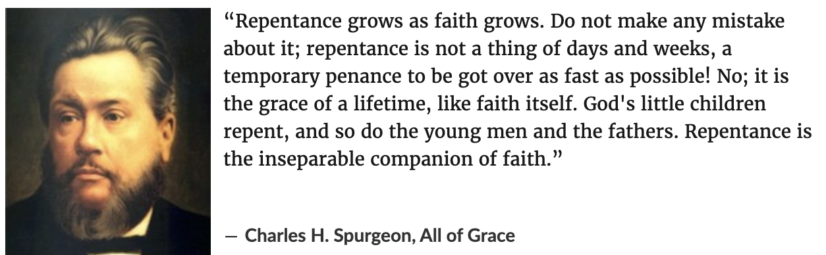

4. Zechariah’s and Jesus’ ministries are similar, as they both start with a call to repentance. Read Matthew 3:1-11 and list the characteristics of repentance and the characteristics of false religion.

5. In Zechariah 1:6 God reveals that the fathers of Israel were temporal, so were the prophets, but what endured forever is His word. The picture God gives is of being “overtaken” by His word. How can we not be ‘overtaken’ but stay in step with God? (Consider Psalm 119:105, Proverbs 4:19, Isaiah 42:16, Luke 1:79.)

6. Zechariah reveals God as ‘the Lord of Hosts’, ‘Yahweh-Sabaoth’ - the ruler of angel armies. God’s control over the ‘Spiritual Realm’ is key in understanding our wrestle against sin. Read Ephesians 6:12. What are some practical ways believers can wrestle against sin? (Consider Ephesians 6:13-18, Zechariah 1:3, James 4:7-9)

